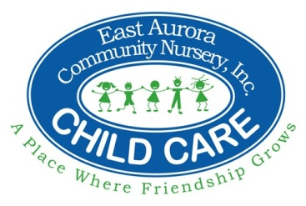

East Aurora Community Nursery

**YEAR-AT-A-GLANCE – 2022-23**

**September, 2022**

1 First Full Day of Fall Session

**5 EACN Closed – Labor Day**

**October, 2022**

31 Halloween Parade – 10 am

**November, 2022**

**24 & 25 EACN Closed – Thanksgiving**

**December, 2022**

1, 5 & 6 – Parent Conferences

**23 & 26 EACN Closed – Christmas**

**January, 2023**

**2 EACN Closed – New Year’s Day**

**April, 2023**

**7 EACN Closed – Good Friday**

**May, 2023**

**29 EACN Closed – Memorial Day**

**June, 2023**

7, 8, & 9 – Parent Conferences

30 Last Day of Fall Session

**July, 2023**

**3 & 4 EACN Closed - Independence Day**

5 First Day of Summer Session

**August, 2023**

29 Last Day of Summer Session

**30 & 31 EACN Closed – Staff Development**